Monitor grouping
Click on IR Groups on Core config tool
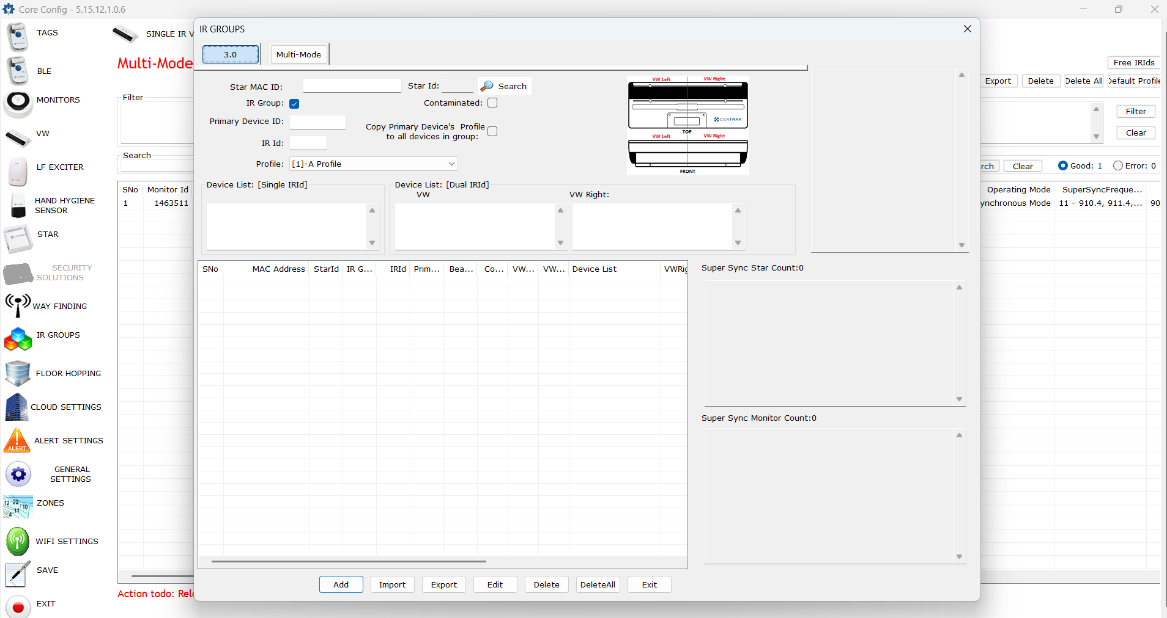

Either search by Star ID Just Click on search
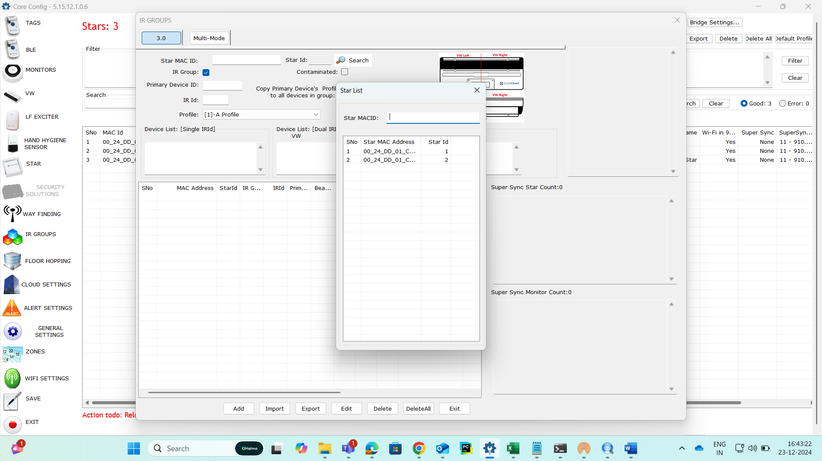

Two monitors
One monitor as primary and split other monitor into two monitors
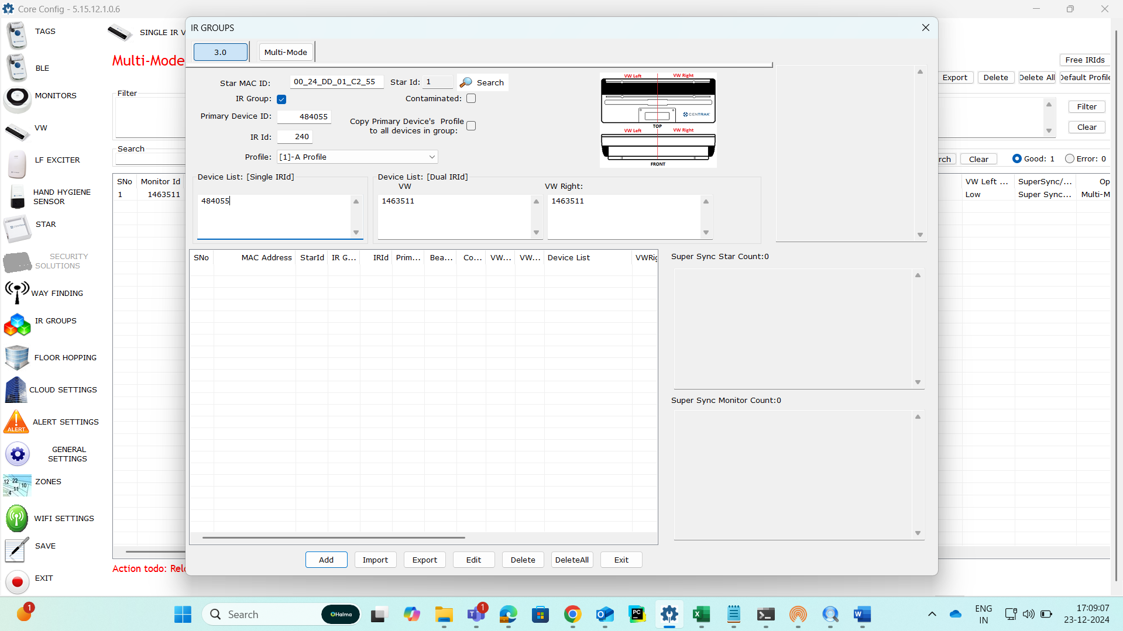

Group all monitors to resolve only one monitor ID by adding them in Device List Single IR ID Section with comma seperated
